**DEEPCYTES REPORT FORMAT**

**General rules: (to be followed on the backend)**

* Name the folder as ‘Report/ToolName_Vertical_YYYYMM_YourName’
* Folder should contain 3 files:
  + Documentation for the work done.
    - The documentation to be named as ‘Doc_ToolName_Vertical_YYYYMM_YourName’
  + .txt file of script for installation
    - The script file to be named as ‘Script_ToolName_Vertical_YYYYMM_YourName’
    - Should include a readme/comments section at the top of the script. (FORMAT TBD)
    - To update the index, click the ‘Update table of contents’ button. 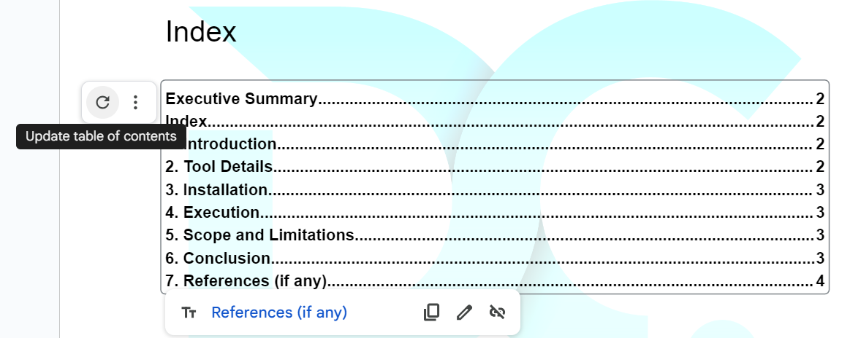
    - Format: Section Headers: Heading 1, Subheaders: Heading 2
  + Demo Video
    - The demo video to be named as ‘Demo_ToolName_Vertical_YYYYMM_YourName’
    - Video format: .mp4
    - Video should include all the use cases as stated in the use cases section in the document.
    - A VO explaining the working must be included.
* Access for this folder should be shared with your Team Manager, [info@deepcytes.io](mailto:info@deepcytes.io) , and any other IDs if mentioned.
* To start editing this document, make a copy and start Page 2 onwards.

**Batch Reverse Geocoding**

**Cyber Intel | geoapify | 24th September 2023**

# Executive Summary

Geoapify is a location data platform that offers a variety of geospatial services, including batch reverse geocoding. Batch reverse geocoding is the process of converting multiple sets of latitude and longitude coordinates into addresses or place names in a single operation.

# Index

Executive Summary 2

Index 2

1. Introduction 2

2. Tool Details 2

3. Installation 3

4. Execution 3

5. Scope and Limitations 6

6. Conclusion 6

7. References 7

# Introduction

Geoapify is a location data platform that provides a variety of geospatial services, including batch reverse geocoding. The Geoapify Reverse Geocoding API allows you to convert latitude and longitude coordinates into addresses or place names in bulk. This can be done by uploading a file containing the coordinates or by sending a POST request with the coordinates

# Tool Details

Link to Tool: <https://www.geoapify.com/tools/reverse-geocoding-online>

Dependencies: NA

Use Cases List:

* Identifying malicious IP addresses
* Detecting fraud
* Investigating cybercrime

Version worked on in the report: NA

Date of run: 24th September 2023

OS used: Windows

GUI/CLI/Web: Web

# Installation

**Not Required**

# Execution

**Use Case 1.** Extract Locations using Latitude and Longitude given in sample file

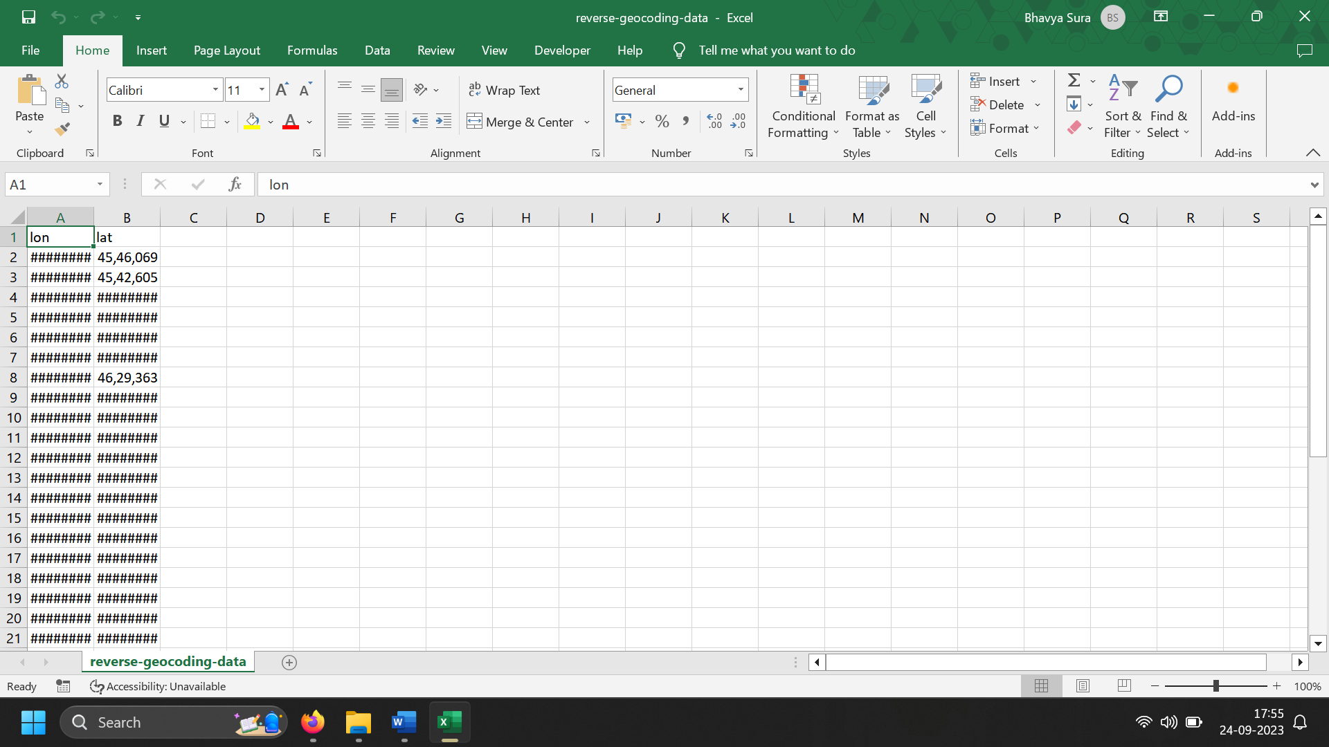

Figure 1: CSV file provided by developers

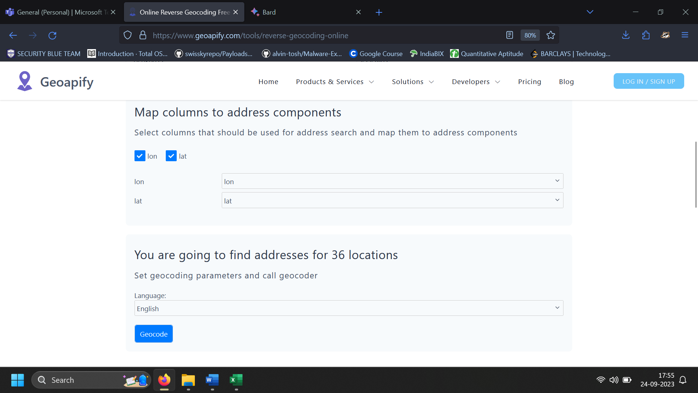

Figure 2: Uploading the file

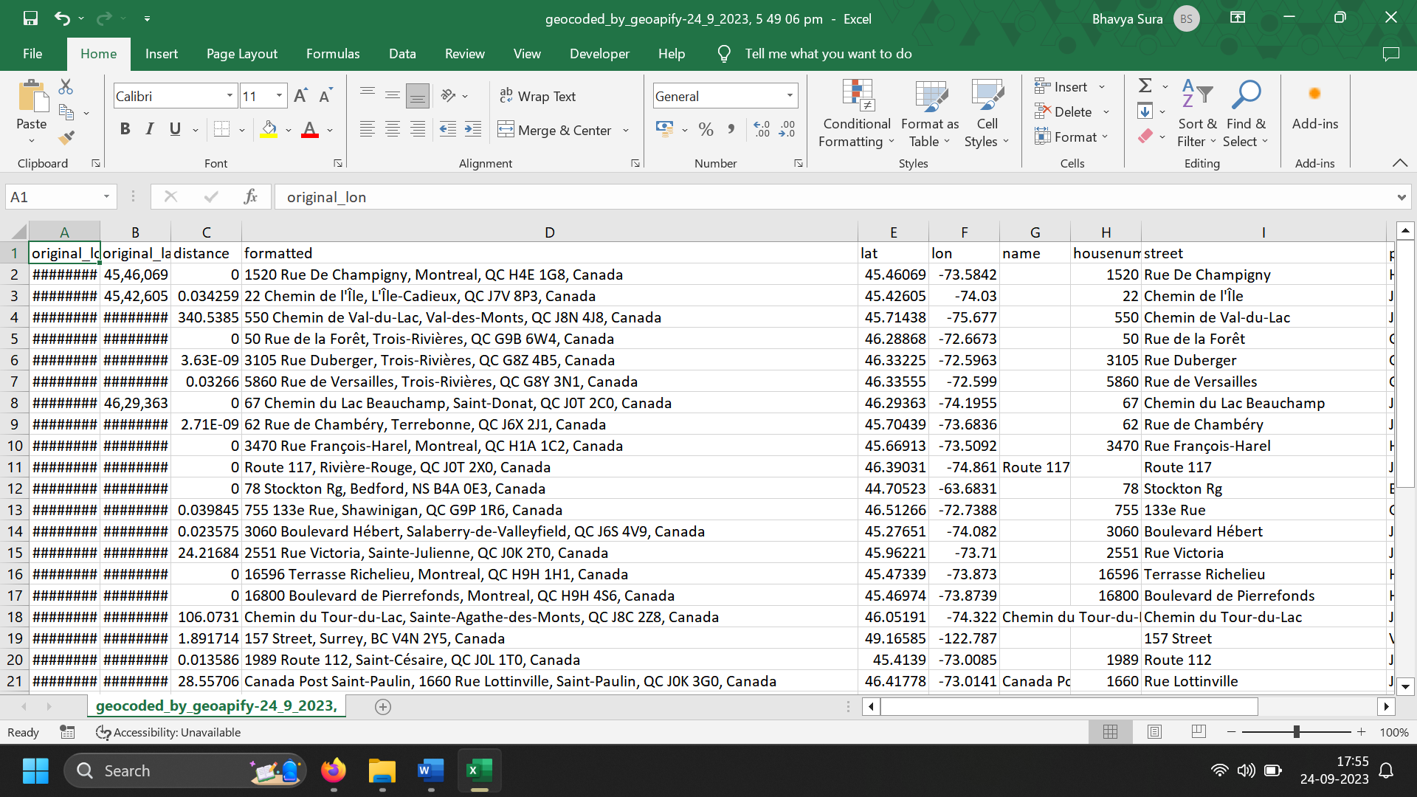

Figure 3: Reverse Geocoded CSV file

**Use Case 2.** Extract Locations using Latitude and Longitude custom excel file

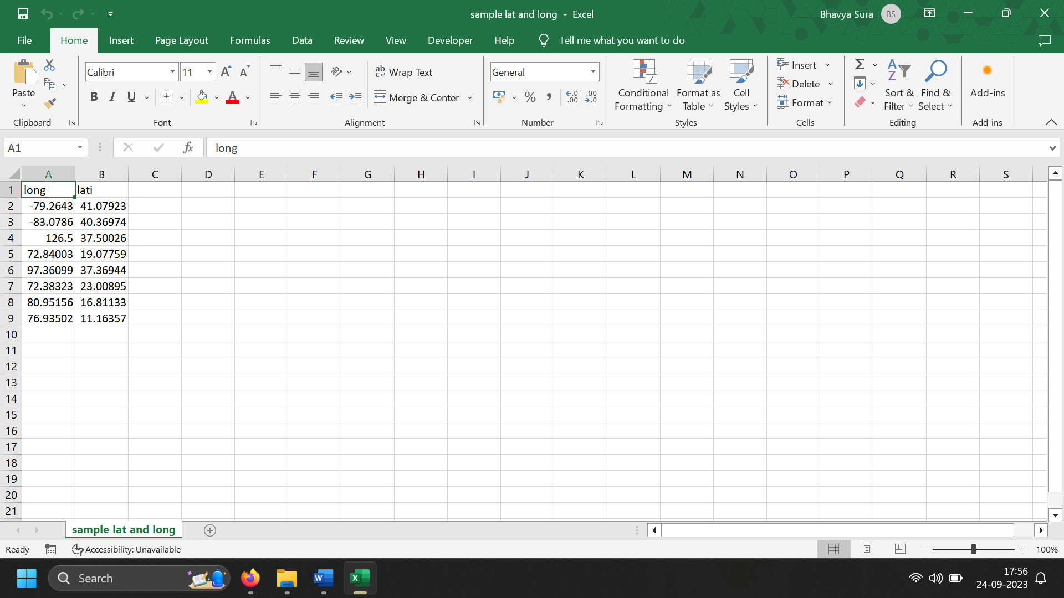

Figure 4: Custom Sample File

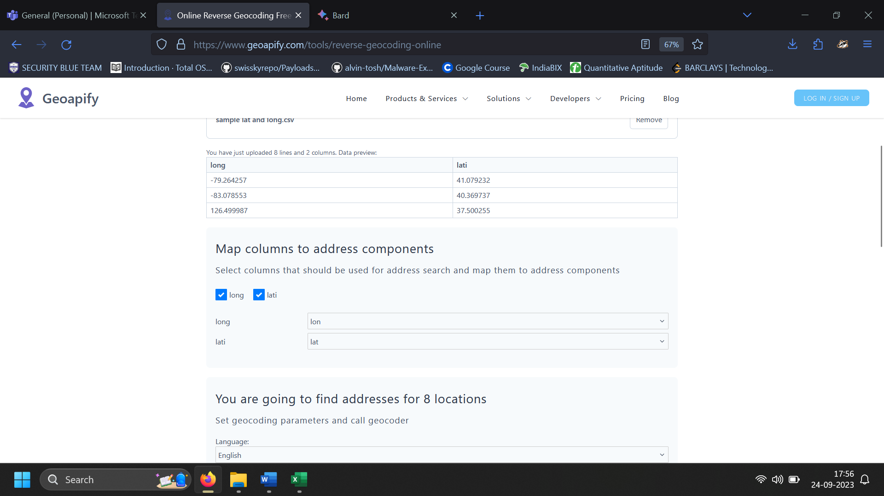

Figure 5: Uploading the file

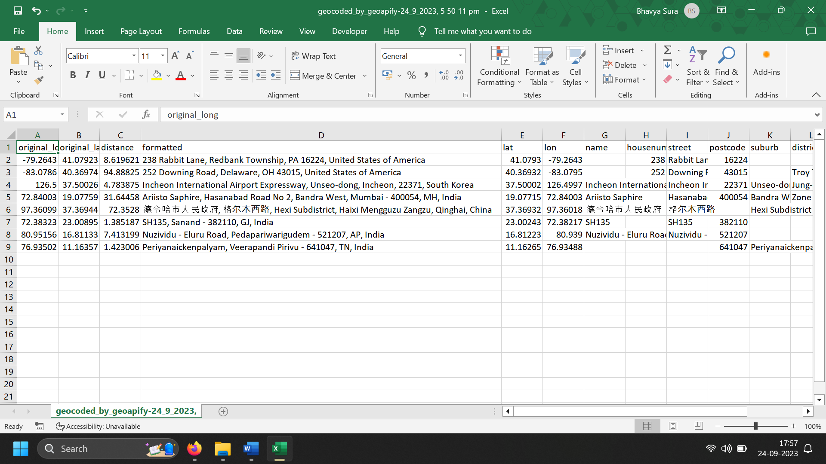

Figure 6: Reverse Geocoded Output File

# Scope and Limitations

* GeoApify has a limit on the number of batch requests that can be made per day. This limit is determined by the plan that a user has subscribed to. For example, the free plan has a limit of 100 batch requests per day.
* It does not provide a way to specify the coordinate system of the input data. This means that the input data must be in the same coordinate system as the GeoApify database. If the input data is in a different coordinate system, it will need to be converted before it can be used with GeoApify.
* GeoApify does not provide a way to filter the results of a batch reverse geocoding request. This means that all of the results will be returned, even if they are not relevant to the user's needs.

# Conclusion

The Geoapify Reverse Geocoding API is a powerful tool for batch reverse geocoding. It is easy to use and provides accurate results. It is also free to use for low volumes.

# References

<https://www.geoapify.com/tools/reverse-geocoding-online>